Risk Assessment - Two Approaches
The basics of risk assessment, modelling, and management have been discussed several times during this module. Many of the risk and threat modelling frameworks that have been discussed and/or are in common use – either provided by standards bodies or proprietary to consulting firms – tend to use qualitative-based assessments – such as risk matrices.
This is where a subjective value (“A subjective value is a risk rating assigned using human judgement and experience rather than exact numerical measurements. It is commonly expressed as Low, Medium, High, or Very High and may vary between assessors.”) is associated with a risk – this value can be numeric or, as shown in the table below, a choice of low, medium, high and so on.
 | HARM SEVERITY
PROBABILITY | Negligible | Marginal | Critical | Catastrophic
Certain | High | High | Very High | Very High
Likely | Medium | High | High | Very High
Possible | Low | Medium | High | Very High
Unlikely | Low | Medium | Medium | High
Rare | Low | Low | Medium | Medium
Eliminated | Eliminated
Risk Matrix Example from Wikimedia
However, many risk experts and consultants (such as Hubbard, 2020) argue that much better, more accurate, and more useful data is available through the use of quantitative approaches.
The main purpose of this lecture cast is to describe and discuss a number of such approaches – that is analysis based on probabilistic or statistical methods such as:
- bullet
The Monte Carlo Simulation.
- bullet
The Bayes Theorem.
- bullet
The Multi-Criteria Decision Analysis (MCDA)

Understanding the Risk Matrix
The matrix combines:
- Probability (Likelihood) – How likely is it to happen?
- Harm Severity (Impact) – How bad will it be if it happens?

Probability
- Certain = Will almost definitely happen
- Likely = Probably happen
- Possible = Might happen
- Unlikely = Not expected
- Rare = Very unlikely

Severity
- Negligible = Almost no damage
- Marginal = Small damage
- Critical = Serious damage
- Catastrophic = Extremely severe damage

Example 1: Lost USB Stick
Probability = Possible
Impact = Marginal
Looking at the matrix:
➡️ Medium Risk

Example 2: Customer Database Breach
Probability = Possible
Impact = Catastrophic
Looking at the matrix:
➡️ Very High Risk
Even if it doesn't happen often, the impact would be devastating.

Example 3: Phishing Attack
Probability = Likely
Impact = Critical
Looking at the matrix:
➡️ High Risk

Why is this approach popular?
Advantages:
- Simple
- Fast
- Easy for managers to understand
- Doesn't require lots of historical data
Disadvantages:
- Subjective
- Two people may score the same risk differently
- Less precise than quantitative methods

Video transcript
The Monte Carlo method was developed by a loosely managed team of mathematicians, statisticians, computer scientists and nuclear scientists in the mid-forties in the USA. It was driven by trying to prove the usefulness of the newly created computer – ENIAC – to post-war problems. The team came up with a computer algorithm that would use older statistical sampling techniques to solve a nuclear problem – that was the problem of neutron diffusion in fissional material (Metropolis, 1987). The solution to this problem helped the Americans build thermonuclear devices. The name for the technique allegedly came from the main statistician (Stanislaw Ulam)'s uncle who was supposed to regularly borrow money so that he could go to Monte Carlo – for gambling it is assumed. A classic example is based on the original use-case for the Monte Carlo method: "Consider a spherical core of fissionable material surrounded by a shell of tamper material. Assume some initial distribution of neutrons in space and in velocity but ignore radiative and hydrodynamic effects. The idea is to now follow the development of a large number of individual neutron chains as a consequence of scattering, absorption, fission, and escape. At each stage a sequence of decisions has to be made based on statistical probabilities appropriate to the physical and geometric factors. The first two decisions occur at time t = 0, when a neutron is selected to have a certain velocity and a certain spatial position. The next decisions are the position of the first collision and the nature of that collision. If it is determined that a fission occurs, the number of emerging neutrons must be decided upon, and each of these neutrons is eventually followed in the same fashion as the first. If the collision is decreed to be a scattering, appropriate statistics are invoked to determine the new momentum of the neutron. When the neutron crosses a material boundary, the parameters and characteristics of the new medium are taken into account. Thus, a genealogical history of an individual neutron is developed. The process is repeated for other neutrons until a statistically valid picture is generated. " (Metropolis, 1987). Decisions are made using the pseudo-random number functions of the underlying hardware. If the random number is denoted by x, which is a real number in the set (0,1) experimental evidence recommends a function f= - ln(x) that models the actual distribution of neutron activity. (ln is the natural log function).

Monte Carlo Simulation – Simple Explanation

What is Monte Carlo Simulation?
A Monte Carlo Simulation is a technique that uses random numbers and repeated experiments to estimate the likelihood of different outcomes.
Think of it as:
"Let's simulate the same situation thousands of times using random values and see what usually happens."
Instead of calculating one answer, Monte Carlo creates many possible scenarios and studies the results.

Why is it called Monte Carlo?
The name comes from the famous gambling destination Monte Carlo.
Because the method relies heavily on randomness, similar to games of chance in a casino.

Why was it invented?
In the 1940s, scientists working with the early computer ENIAC needed a way to solve extremely complex nuclear physics problems.
The calculations were too difficult to solve directly.
So they used:
- Random sampling
- Thousands of repeated calculations
- Statistical analysis
to estimate the answer.

Simple Example (Everyday Life)
Imagine you want to know:
"What is the chance of arriving late to work?"
Several factors affect this:
- Traffic
- Weather
- Train delays
- Road accidents
You cannot predict exactly.
Instead, a Monte Carlo simulation might:
- Simulate 10,000 mornings
- Randomly vary traffic and weather
- Record whether you are late
Results might show:
- 65% arrive on time
- 25% arrive 5–10 minutes late
- 10% arrive more than 10 minutes late
This gives a realistic picture of risk.

Monte Carlo in Cybersecurity
Suppose a company wants to estimate annual cyber losses.
Traditional qualitative assessment:
Risk = High
Monte Carlo assessment:
- Simulate 50,000 attack scenarios
- Vary attack frequency
- Vary recovery costs
- Vary downtime
Result:
- Average annual loss = £80,000
- Worst-case loss = £500,000
- 90% probability losses stay below £150,000
This gives much richer information.

What is happening in the neutron example?
The text describes tracking individual neutrons inside nuclear material.
For each neutron, the computer randomly decides:
- Where it moves
- Whether it collides
- Whether it gets absorbed
- Whether it causes fission
- Whether it escapes
The decision is based on known probabilities.
For example:
Event | Probability
Absorption | 20%
Scattering | 50%
Fission | 30%
The computer generates a random number.
If the random number is:
- 0.10 → Absorption
- 0.40 → Scattering
- 0.80 → Fission
This process is repeated thousands or millions of times.
Eventually a statistically reliable picture emerges.

What does "statistically valid picture" mean?
It means:
After enough simulations, the results become trustworthy.
Example:
Simulate 5 times → unreliable.
Simulate 500,000 times → much more accurate.

What are pseudo-random numbers?
Computers cannot create truly random numbers.
Instead they create numbers that appear random.
Example:
0.34
0.87
0.15
0.62
0.91
These are called pseudo-random numbers.
Monte Carlo simulations use these numbers to make random decisions.

What does this mean?
The text says:
[
f = -\ln(x)
]
where:
- x = random number between 0 and 1
- ln = natural logarithm
This formula converts a random number into a value that better matches how neutrons behave in reality.
For example:
If:
[
x = 0.5
]
then:
f=-\ln(x)
[
f = -\ln(0.5)
]
[
f \approx 0.693
]
The formula helps transform simple random numbers into realistic scientific behaviour.
You do not need to calculate this manually for your seminar—just understand its purpose.

Advantages of Monte Carlo Simulation
✅ Handles uncertainty well
✅ Works with many variables
✅ Produces realistic risk estimates
✅ Useful when exact calculations are impossible
✅ Widely used in cybersecurity, finance, engineering, insurance, and project management

Disadvantages
❌ Requires lots of computing power
❌ Results depend on the quality of input data
❌ Can be complex to build
❌ Poor assumptions lead to poor results

Seminar Answer (Short Version)
What is Monte Carlo Simulation?
Monte Carlo Simulation is a quantitative risk modelling technique that uses random sampling and repeated simulations to estimate the probability of different outcomes under uncertainty.
Why is it useful?
It helps organisations model complex risks, evaluate uncertainty, estimate potential losses, and support decision-making using statistical evidence rather than subjective judgement.

Easy Memory Trick
Risk Matrix = Expert Opinion
➡️ "High Risk"
Monte Carlo = Thousands of Simulated Experiments
➡️ "There is a 15% chance of losing more than £100,000."
So:
- Risk Matrix = Qualitative & Subjective
- Monte Carlo = Quantitative & Data-Driven

Principles and Anti-Patterns of the Monte Carlo Simulations
Principles and Anti-Patterns of the
Monte Carlo Simulations
Principles
Always be clear what probability distribution (PD) you have used for the Monte Carlo
Simulation and justify its selection as the selection of this has a large bearing on the accuracy
of the simulation output. In addition, it is recommended that the PD is selected based on
empirical evidence.
Graphs are very useful as they show how quickly the numbers approach the expected value,
plus any outliers, etc.
The quality of the pseudo-random number generator can have a large effect on the simulation
output – so it is worth knowing how it is generated. (Burmaster and Anderson, 1994).
Anti-patterns
1.
2.
3.
4.
Consider carefully the tools used to run the simulation. As mentioned above, the Monte Carlo
method (MCM) can be very sensitive to the pseudo-random number algorithm used, and pre
packaged add-ins or tools give no control over what is used.
The sampling method can have a big impact, which again can be related back to point 1.
MCM does not work well with non-standard distributions, or indeed if the user mismatches the
PD and the real-world distribution of data.
Because it is computationally intensive, many-dimensional simulations do not work well.
(Marsden, 2018)
‌The list of distributions (and examples of real-world events that fit them) comes from Marsden (2018). He also comments that the SciPy stats package has individual libraries for each of the mentioned distributions. As discussed previously, it is important to select the correct distribution to match the real-world event(s) that need to be modelled, or the simulations will not provide valid predictions/ data.
Real World Event | Probability Distribution
Coin tossing with uneven coin. | Bernoulli.
Rolling a dice. | Uniform.
Counting errors/successes. | Binomial.
Trying until success. | Geometric.
Countable, rare events whose occurrence is independent. | Poisson.
Random "noise", sums of many variables. | Normal.

Bayes Theorem
Bayes Theorem is a statistical theory of conditional probabilities. It was named after the Rev Thomas Bayes but was not actually published until after his death by a colleague – Richard Price.
Indeed, some argue that it should be called the Bayes-Price theorem. (Mitchell, 1911).
The theorem is shown in the figure where:
- p(A|B) refers to the probability of A given that B is true;
- P(A) is the probability of A; p(B|A) is the probability of B given that A is true;
- p(B) is the probability of B.
- Sometimes, p(A) is called the prior probability;
- p(A|B) is known as the posterior probability;
- p(B|A) is known as the likelihood (especially when A denotes some data);
- p(B) is known as the normalising constant.

Bayes Theorem from ThinkBay
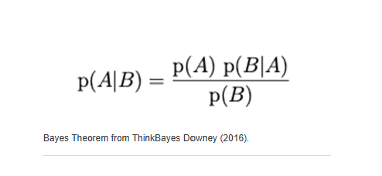
10. Bayes Theorem (Beginning of Lecture)
Bayes Theorem updates probabilities when new information becomes available.
Simple idea:
"Old belief + New evidence = Updated belief"
Important terms:
- Prior Probability = Initial belief
- Likelihood = New evidence
- Posterior Probability = Updated belief
- Normalising Constant = Adjustment factor

Principles and Anti-Patterns of the Bayes Theorem
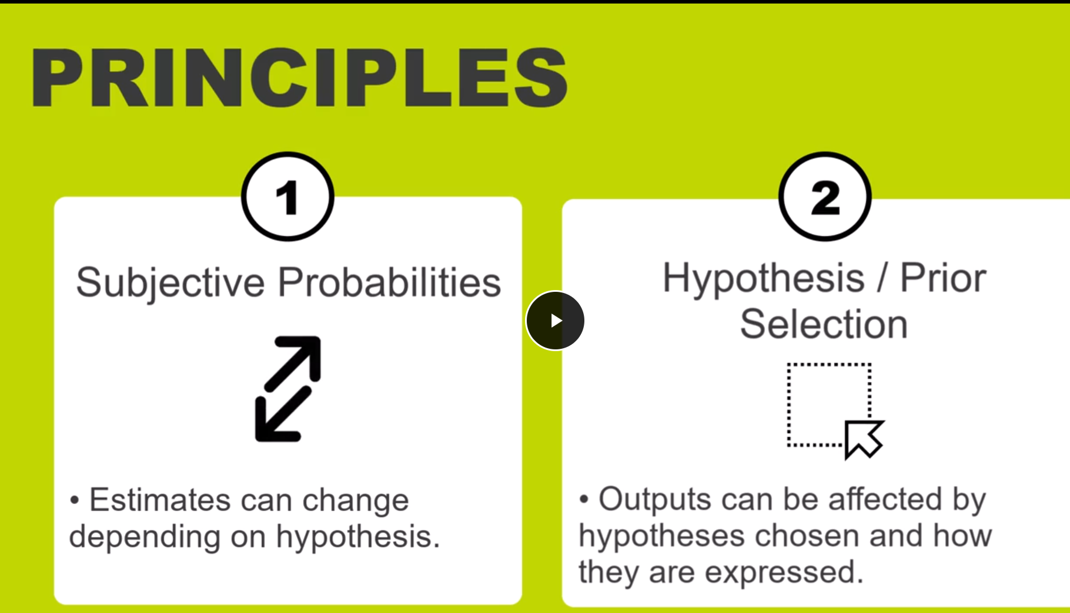

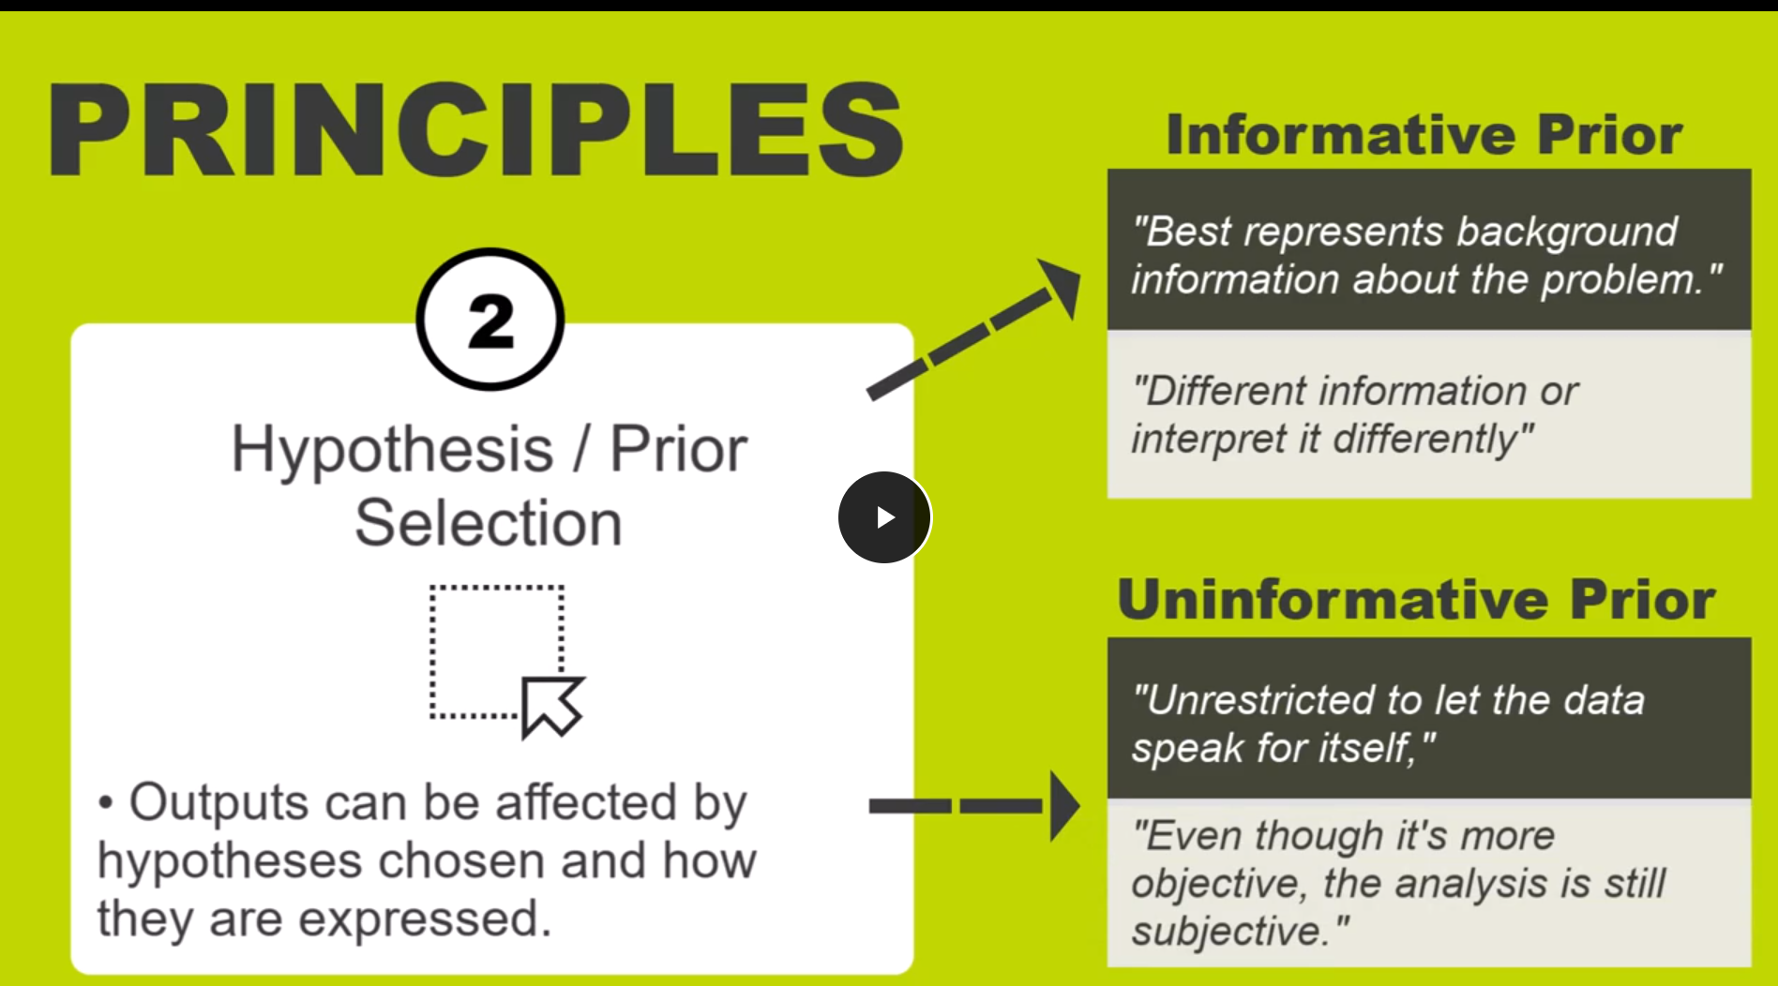

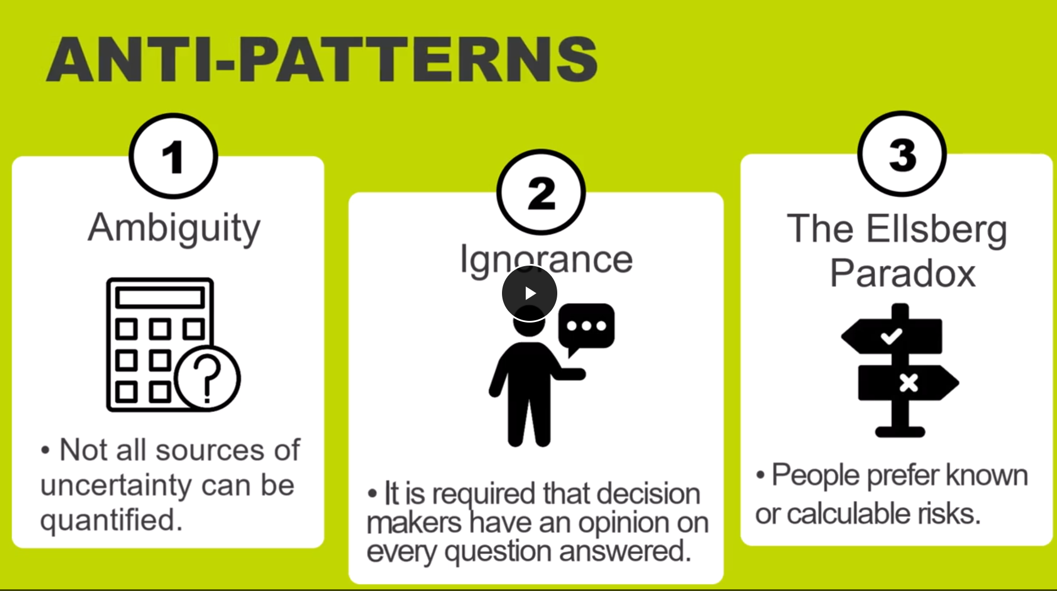

Principles and Anti-Patterns of Bayes Theorem
Think of Bayes Theorem as:
"Start with an initial belief and update it when new evidence appears."

PRINCIPLE 1: Subjective Probabilities

What does it mean?
Bayes requires people (decision makers) to have an initial opinion or belief before calculations start.
Different people may start with different beliefs.
Therefore:
Different people may get different results.

Example:
Question:
What is the probability our company will experience a ransomware attack next year?
Person A says:
10%
Person B says:
25%
Both may later receive the same new evidence, but because they started differently, they may still end with different results.

Simple sentence to remember:
Bayes depends partly on human judgement.

PRINCIPLE 2: Prior (Initial Belief) Selection ⭐⭐⭐
The Prior is:
Your starting probability before seeing any new evidence.
There are two approaches.

A) Informative Prior
Use existing knowledge.
Example:
You already know:
- Your company had 3 phishing attacks last year.
- Your industry is heavily targeted.
So you start with:
30% probability.
Advantage:
✅ Uses real experience.
Disadvantage:
❌ Different people may interpret information differently.

B) Uninformative Prior
Start with very little assumption.
Basically:
"Let the data speak for itself."
Example:
You know nothing.
So you start neutral.
Advantage:
✅ More objective.
Disadvantage:
❌ Still not completely objective.

What is Downey (2016) saying?
He says:
Even if you use an uninformative prior, the analysis is still subjective because humans still make decisions.
In simple words:
Bayes can never be 100% objective.

ANTI-PATTERN 1: Ambiguity
Some things cannot be predicted mathematically.
Examples:
❌ Price of copper in 20 years.
❌ Likelihood of a future war.
Too many unknown factors exist.
Bayes does not work well here.

Simple sentence:
If uncertainty is impossible to estimate, Bayes struggles to help.

ANTI-PATTERN 2: Cannot Express Ignorance ⭐⭐⭐
Bayes forces you to provide an answer.
Sometimes:
You simply do not know.
But Bayes still asks:
Give a probability.
If you invent a number:
The final result may become misleading.

Example:
Question:
What is the probability of a cyberattack next year?
You have no data.
But you guess:
50%
Your entire calculation may now be wrong.

Simple sentence:
Guessing creates inaccurate results.

ANTI-PATTERN 3: Ellsberg Paradox ⭐⭐⭐
This means:
People prefer known risks over unknown risks.

Example:
Option A:
50% chance of losing £100.
Option B:
Unknown chance of losing money.
Most people choose:
Option A
because they know the risk.
People dislike uncertainty.
This is called:
Ambiguity aversion.

EASY MEMORY TABLE ⭐
Principles | Meaning
Subjective probabilities | People start with different beliefs
Prior selection | Choosing your starting probability

Anti-Patterns | Meaning
Ambiguity | Some things cannot be predicted
Cannot express ignorance | Bayes forces you to guess
Ellsberg paradox | Humans prefer known risks

Seminar Cheat Sheet (Very Important ⭐⭐⭐)
If the tutor asks:
What are the limitations of Bayes Theorem?
You can answer:
Bayes Theorem has three main limitations. First, it is subjective because different decision makers may start with different prior beliefs. Second, it cannot handle situations where there is very little information, because users are forced to estimate probabilities. Third, it struggles with ambiguous situations, such as predicting wars or long-term commodity prices, and people naturally prefer known risks over unknown risks (Ellsberg paradox).

30-second memory trick
Bayes = BELIEF + EVIDENCE = NEW BELIEF
Problems to remember:
A-G-E
A = Ambiguity
G = Guessing (cannot express ignorance)
E = Ellsberg paradox
If you remember AGE, you'll remember all three anti-patterns.
Would you like this current conversation deleted or not?

The M&M Problem

The M&M Problem (Simple Explanation)
The company changed the colour distribution of M&Ms in 1995.

Before 1995 (1994 bag)
Colour | Percentage
Brown | 30%
Yellow | 20%
Red | 20%
Green | 10%
Orange | 10%
Tan | 10%

After 1995 (1996 bag)
Colour | Percentage
Blue | 24%
Green | 20%
Orange | 16%
Yellow | 14%
Red | 13%
Brown | 13%
Notice:
- Yellow became less common (20% → 14%)
- Green became more common (10% → 20%)

The situation
Your friend has:
- One bag from 1994
- One bag from 1996
But you don't know which bag is which.
She gives you:
- Bag 1 → Yellow M&M
- Bag 2 → Green M&M
Question:
What is the probability that the yellow M&M came from the 1994 bag?

Bayes thinking
We create two possible hypotheses.

Hypothesis A
Bag 1 = 1994
Bag 2 = 1996

Hypothesis B
Bag 1 = 1996
Bag 2 = 1994

Step 1: Prior Probability
Initially:
We have no information.
Both possibilities are equally likely.
So:
A = 50%
B = 50%
or
$$\frac{1}{2}$$

Step 2: Check the evidence
We observed:
- Bag 1 = Yellow
- Bag 2 = Green

If A is true
Bag 1 = 1994
Yellow in 1994 = 20%
Bag 2 = 1996
Green in 1996 = 20%
Multiply:
20 × 20 = 400
(They simplified it to 200 because of the ½ prior.)

If B is true
Bag 1 = 1996
Yellow in 1996 = 14%
Bag 2 = 1994
Green in 1994 = 10%
Multiply:
14 × 10 = 140
(They simplified it to 70.)

Step 3: Compare
Hypothesis | Score
A | 200
B | 70
Total:
270

Step 4: Convert to probabilities
For A:
$$\frac{200}{270}$$
=
$$\frac{20}{27}$$
≈ 74%

For B:
$$\frac{70}{270}$$
=
$$\frac{7}{27}$$
≈ 26%

Final answer
There is about a 74% probability that the yellow M&M came from the 1994 bag.
Bayes Theorem updates an initial probability (prior belief) using new evidence to calculate a more accurate probability (posterior probability).

Simple cybersecurity example (similar idea)
Initially:
There is a 50% chance a server is compromised.
New evidence:
Antivirus detects malware.
Updated probability:
There is now an 85% chance the server is compromised.
That is exactly what Bayes is doing.
Click to flip
The color mix in a bag of plain M&M’s was:
- 30% Brown,
- 20% Yellow,
- 20% Red,
- 10% Green,
- 10% Orange,
- 10% Tan.
Click to flip
The color mix in a bag of plain M&M’s was:
- 24% Blue,
- 20% Green,
- 16% Orange,
- 14% Yellow,
- 13% Red,
- 13% Brown.
Suppose a friend of mine has two bags of M&M’s, and she tells me that one is from 1994 and one from 1996. She will not tell me which is which, but she gives me one M&M from each bag. One is yellow (from bag 1) and one is green (from bag 2). What is the probability that the yellow one came from the 1994 bag?
The table shows that hypothesis A is the most likely. Downey provides a version online that is built using the Python PANDAS library. From Downey (2016).
Hypothesis | Prior p (H) | Likelihood p (D|H) | Product p (H) p (D|H) | Posterior p (H|D)
A | 1/2 | (20)(20) | 200 | 20/27
B | 1/2 | (14)(10) | 70 | 7/27
Total | 1 |  | 270 (Norm)
Hyp A: Bag 1 is from 1994; Bag 2 is from 1996.
Hyp B: Bag 2 is from 1994; Bag 1 is from 1996.

Multiple Criteria Decision Analysis

People face decision problems every day.

Computing (and statistics) can offer various support tools to assist with the 'decision' problem, which are classed under the general heading of multi-decision criteria analysis (MCDA).
The 'Decision Problem' (Ishizaka and Nemery, 2013) can be subdivided into a number of categories such as:
Choice
–
Choosing the best energy supplier based on cost and customer service; selection of a single 'best' option.
Sorting
–
Based on classifications such as possible illness based on symptoms, etc; useful in repetitive tasks.
Ranking
–
When choosing a suitable university based on its rankings for research, teaching, fees, and so on.
Description
–
Describing options and their consequences which can apply to many of the other categories.
Elimination
–
This is a specific case of the sorting problem, when options may be eliminated.
Design
–
The unique aspect of this category is the design of a new action to satisfy the problem in question.
Elicitation
–
Designed to elicit preferences for a specific problem and/ or MCDA method.

Cybersecurity examples (very useful)

Monte Carlo
Question:
How much could a ransomware attack cost next year?

Bayes
Question:
Given a security alert, what is the probability we are under attack?

MCDA
Question:
Which cybersecurity tool should we purchase?
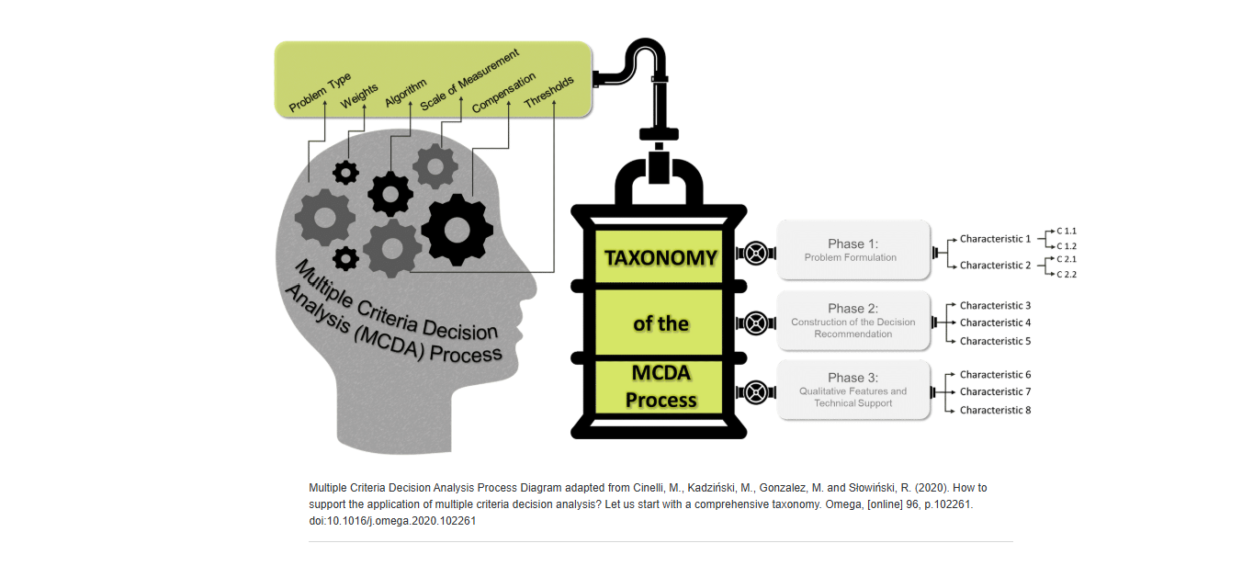

Memory sentence ⭐⭐⭐
Imagine three people in a meeting.

Monte Carlo says:
"Let's simulate 50,000 futures."

Bayes says:
"We have new evidence. Update our probability."

MCDA says:
"We have many options. Let's choose the best one."
My favourite memory trick for you ⭐⭐⭐
Monte Carlo = FUTURE
Bayes = EVIDENCE
MCDA = DECISION
If you remember:
Future → Evidence → Decision
Lesson 9 of 14

Principles and Anti-Patterns of the Multiple Criteria Decision Analysis

PRINCIPLES
Selecting the appropriate method is a two-step process:
- 1
1
Select the type of decision that is required (I.e., ranking, choice, etc.) then use the table provided to select the range of methods that can calculate those type of decision outcomes.
- 2
2
Chose which of the possible techniques you would prefer to use – this may be driven by availability of tools or the difficulty in preparing and acquiring the input data.
These two steps should pretty much direct you to a single (or a narrow range of) tool(s) to select. The correct preparation of data is important – for example with the pairwise comparison of data.
Some techniques (such as ANP) are notoriously complex in how the data is prepared (Asadabadi et al, 2019).
Finally the selection of tools is important because it will drive compatibility with data sources and also the flexibility of data presentation.

Depending on the skill set of the user the choice ranges from third party commercial packages, spreadsheet models or self-created applications in languages such as python.

ANTI-PATTERNS
The flip side of the principle of selecting the correct method is the ease in which the wrong method can be selected.

INCORRECT SELECTION
Incorrect selection can result in extensive work in preparing data that turned out to be unnecessary, through to erroneous outputs generated by the use of inappropriate techniques.
RANK REVERSAL
Rank reversal is related to the change in the ranking of alternatives when a criterion or an alternative is added or dropped - this removal can lead to a complete reversal of output ranking.

ACCURACY
A research study (summarised in Çelikbilek & Tüysüz, 2020) shows that some techniques (such as AHP and VIKOR) are more accurate than others (such as TOPSIS) for the same data sets (this is once again related to the correct selection of techniques).
Finally some methodologies – such as ANP – use complex rules for pairwise prioritisation. These can often be difficult for users to process correctly which may lead to incorrect or wildly variable outputs.
EXPLAIN:
=

Imagine you are a cybersecurity manager
You ask three different questions.

Monte Carlo asks:
What could happen in the future?
Example:
How much money could ransomware cost us next year?
It runs:
- 50,000 attack simulations
- Different attack frequencies
- Different recovery costs
Answer:
There is a 15% chance losses will exceed £100,000.
It is a future prediction tool.

MCDA asks:
Which option is the best overall choice?
Example:
Which antivirus should we buy?
Consider:
- Cost
- Security
- Ease of use
- Customer support
Answer:
Vendor B is the best overall option.
It is a decision-making tool.

Bayes asks:
Given some NEW evidence, how should I change my belief?
Example:
At 9:00 AM:
I think there is a 5% chance our server is compromised.
At 9:30 AM:
You receive an IDS alert.
Now Bayes says:
Don't keep believing 5%.
Update your belief.
Maybe now:
There is a 30% chance the server is compromised.
Bayes is an evidence-updating tool.

Decision Problems vs. MCDA Techniques
The table shows a number of categories with a selection of MCDA methods that can be used for problems that occur in those categories. This lecturecast will (briefly) discuss TOPSIS, AHP and ANP, although a number of the other techniques are covered in the recommended course text.
As the table also illustrates, there are a number of software solutions available including commercial packages, spreadsheet models and python implementations, depending on user preferences.
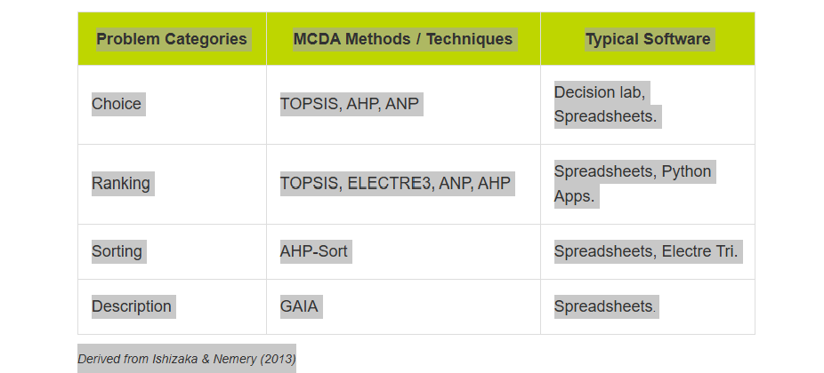
Problem Categories | MCDA Methods / Techniques | Typical Software
Choice | TOPSIS, AHP, ANP | Decision lab, Spreadsheets.
Ranking | TOPSIS, ELECTRE3, ANP, AHP | Spreadsheets, Python Apps.
Sorting | AHP-Sort | Spreadsheets, Electre Tri.
Description | GAIA | Spreadsheets.

Comparison of Techniques
Perfect, Payman. Don't get overwhelmed by the names. AHP, ANP and TOPSIS are simply three different tools that belong under MCDA.
Risk Assessment

Qualitative
│
└── Risk Matrix

Quantitative
│
├── Monte Carlo
│ ↓
│ Simulate thousands of futures
│
├── Bayes Theorem
│ ↓
│ Update probabilities with new evidence
│
└── MCDA
↓
Choose the best option

│
├── AHP
├── ANP
└── TOPSIS

Easy comparison table
Method | Simple idea | Memory phrase
AHP | Compare two items at a time | Ask in Pairs
ANP | Advanced AHP where everything is connected | Network/Web
TOPSIS | Choose the option closest to ideal | Closest to Perfect

